**Guide lines**

**Step 1:** You need to open the home.html file in the browser.

**Step 2:** Click the small bot icon in the right corner of the website. OR click the try chat bot button in the left corner of the website.

**Step 3:** Enter the question and click the send button.

Web Interface

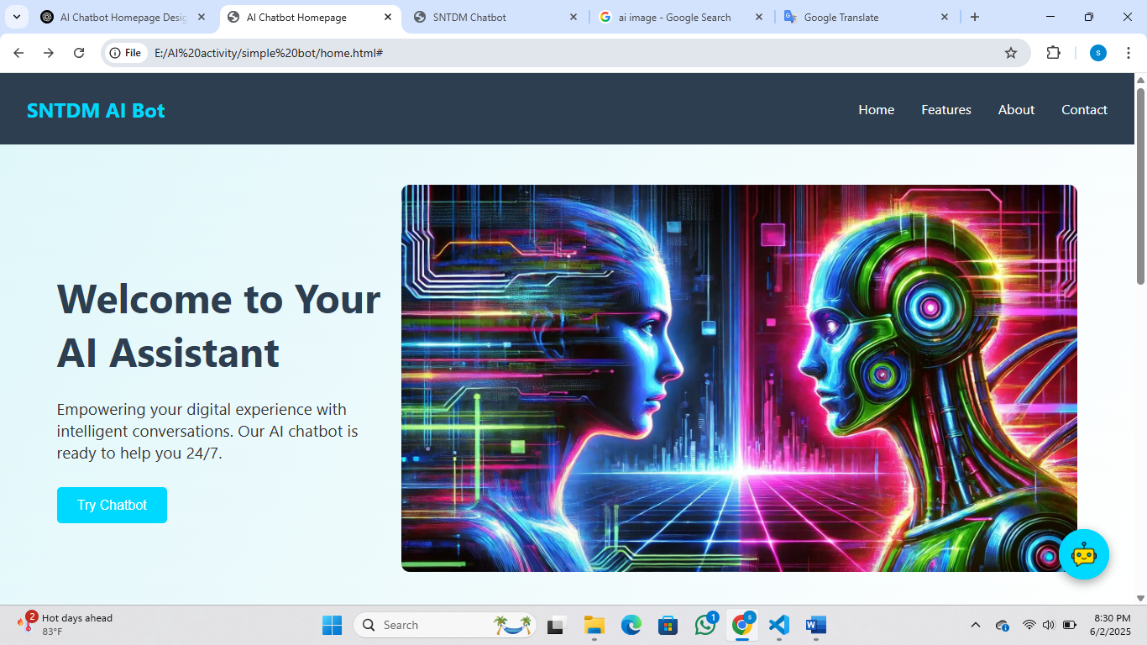

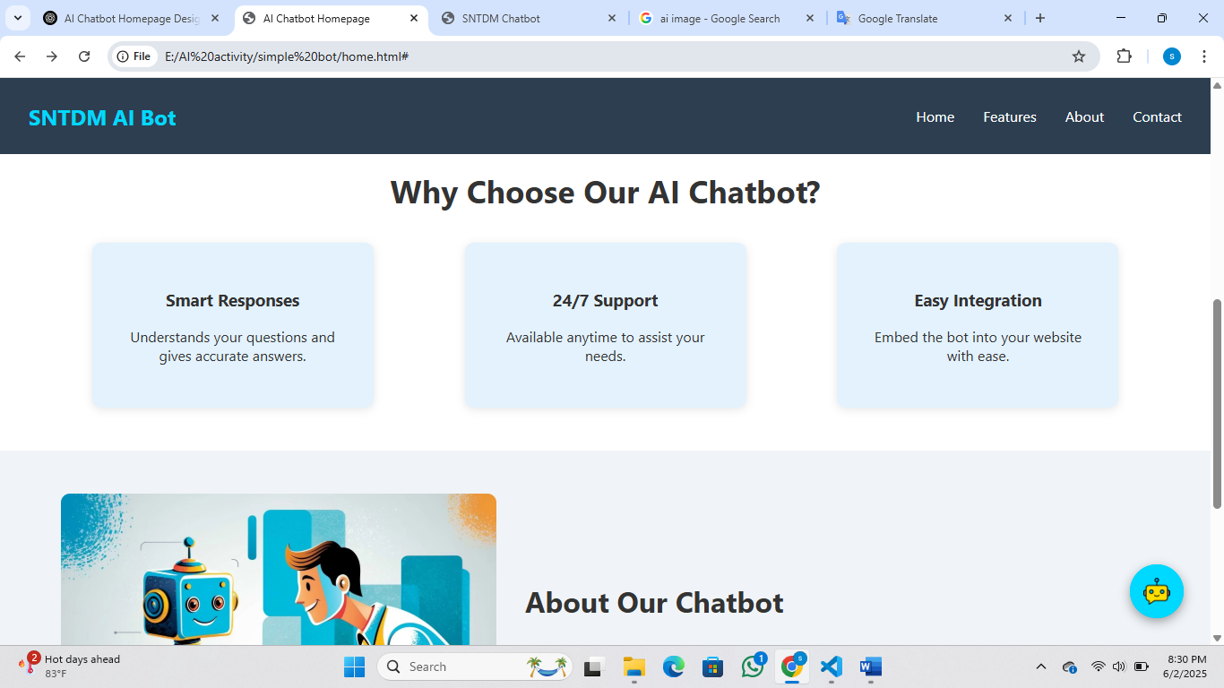

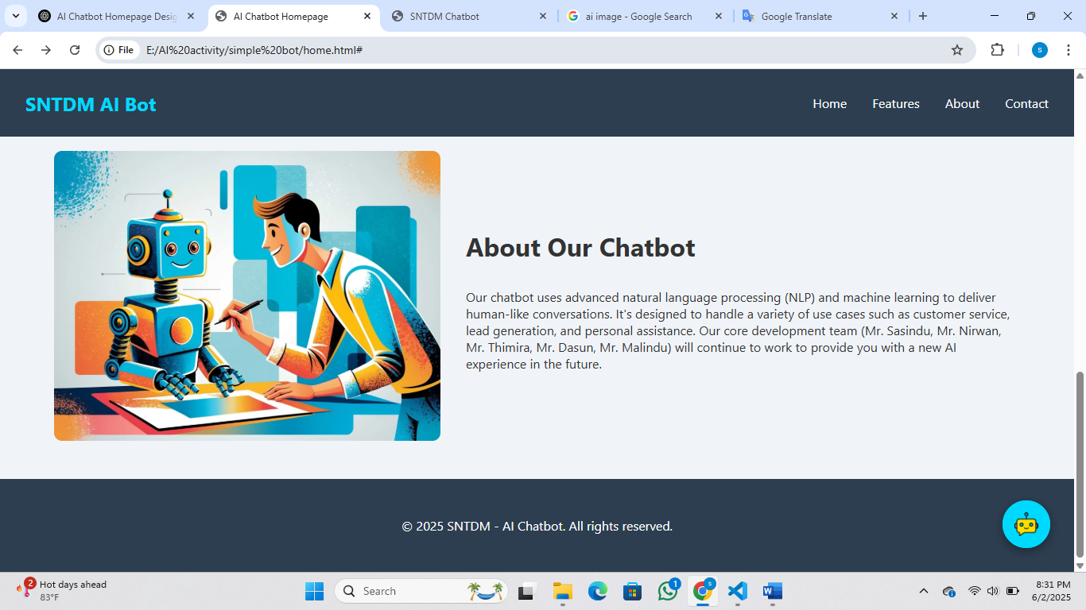

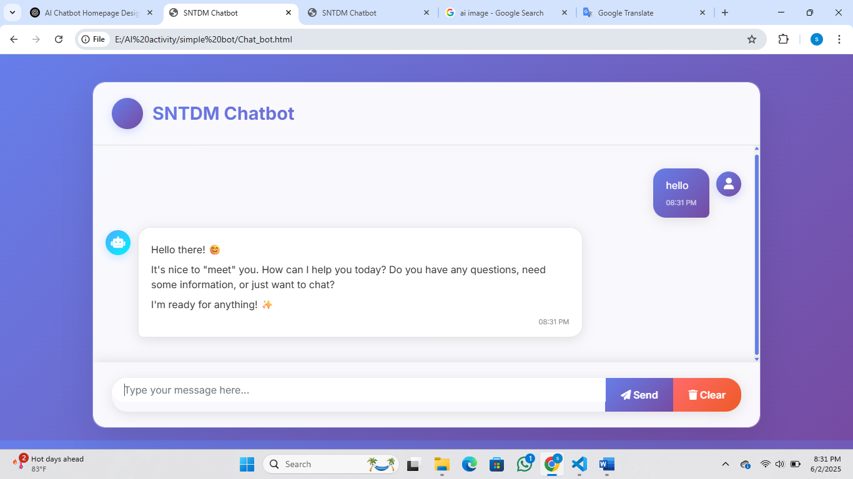

**Group Members,**

* GAM/IT/2022/F/0051
* GAM/IT/2022/F/0058
* GAM/IT/2022/F/0059
* GAM/IT/2022/F/0097
* GAM/IT/2022/F/0108